**SRM ARTS AND SCIENCE COLLEGE**

**KATTANKULATHUR**

DEPARTMENT OF ELECTRONICS AND COMMUNICATION

I Revolution: A Data- Driven Exploration of Apple’s iPhone impact in India

TEAM MEMBERS

1. BALACHANDAR.A

2. YASHWIN. A. R

3. SANDHIYA.D

4. VIDHYA.P

TABLE OF CONTENT

1.INTRODUCTION

1.1 OVERVIEW

1.2 PURPOSE

2.PROBLEM DEFINITION & DESIGN THINKING

2.1 EMPATHY MAP

2.2 IDEATION BRAINSTORMING MAP

3.RESULT

4.ADVANTAGES & DISADVANTAGES

5.APPLICATION

6.CONCLUTION

7.FUTURE SCOPE

**1.INTRODUCTION**

1.1 OVERVIEW

In this project our aim is to comprehensively project in various dimensions like Model specification country wise bestselling smartphone, annual revenue, Brand price comparison, etc…We are going to analysis the dataset collected by using data visualization tool of tableau. Based on the information obtained using the data visualization tool of tableau, we can understand the recent trend and predict the future trend.

1.2 PURPOSE

Our purpose is to analyse the iPhone impact in India.

**2.PROBLEM DEFINITION & DESIGN THINKING**

2.1 EMPATHY MAP

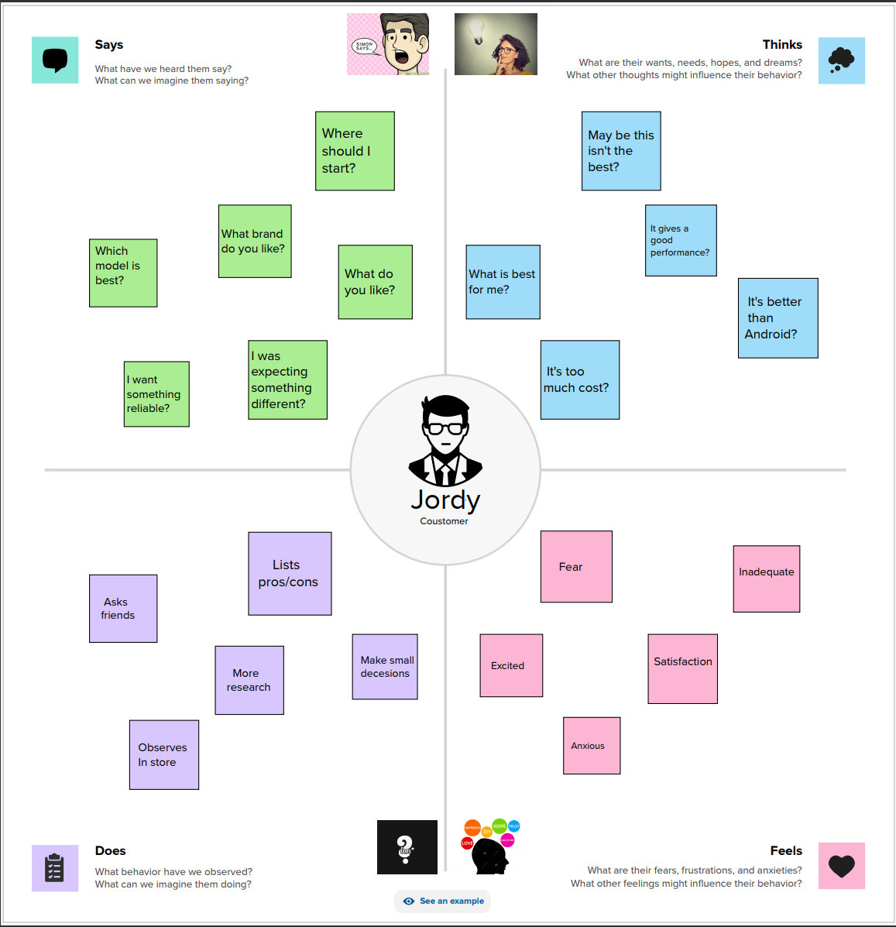

2.2 BRAINSTORMING MAP

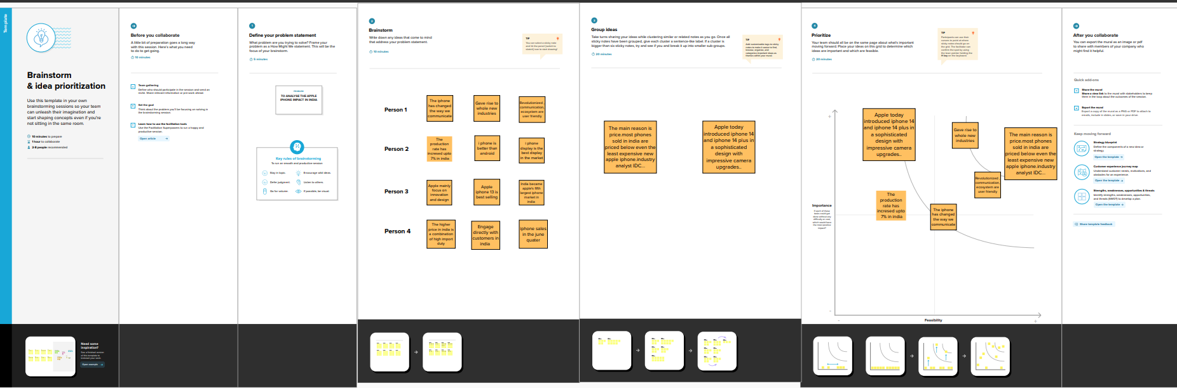

**3.RESULT**

* The iPhone company will generate $394.3 billion in revenue annually by 2022.
* Compared to other models, the iPhone 13 has sold well in India.
* Every year, Apple releases new iPhone models and Ios updates.
* iPhone sales generated $205 billion revenue for apple in 2022, more than Microsoft’s total revenue.
* As of 2023, the market share of iPhone in India is 3.55%.

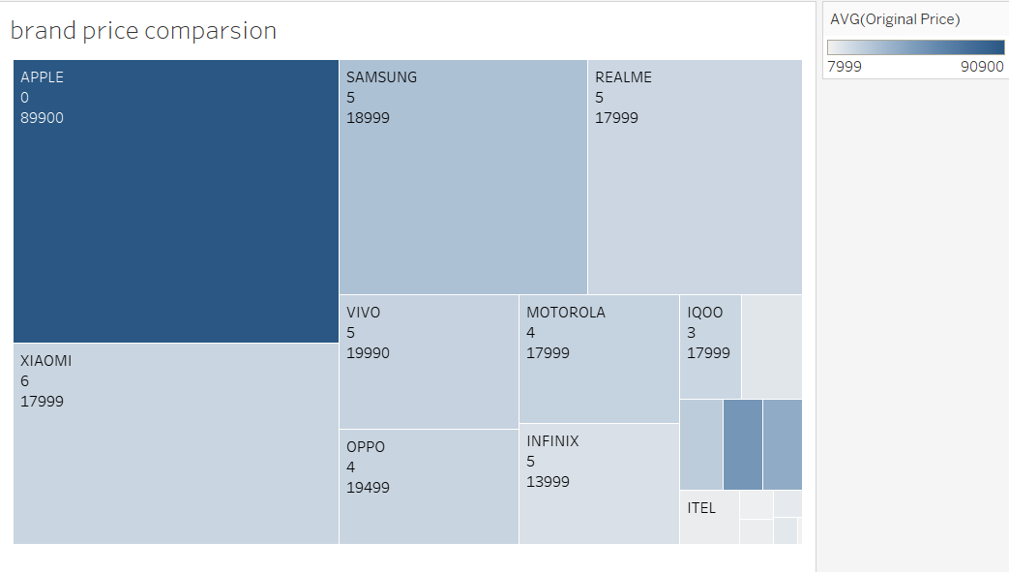

**BRAND PRICE COMPARSION**

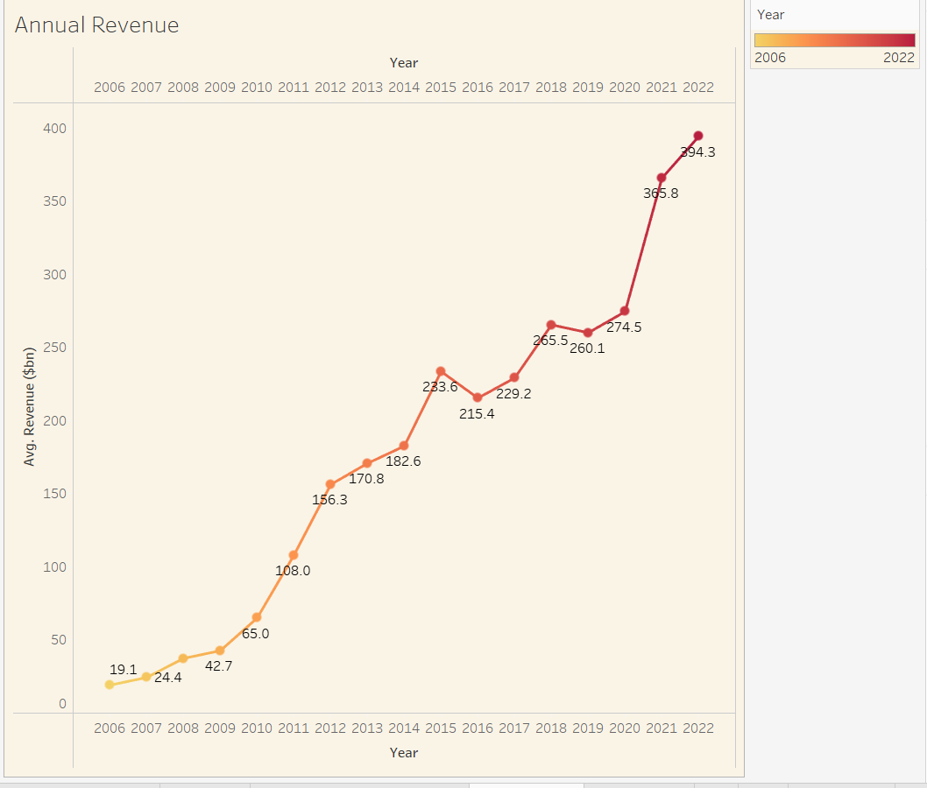

**ANNUAL REVENUE**

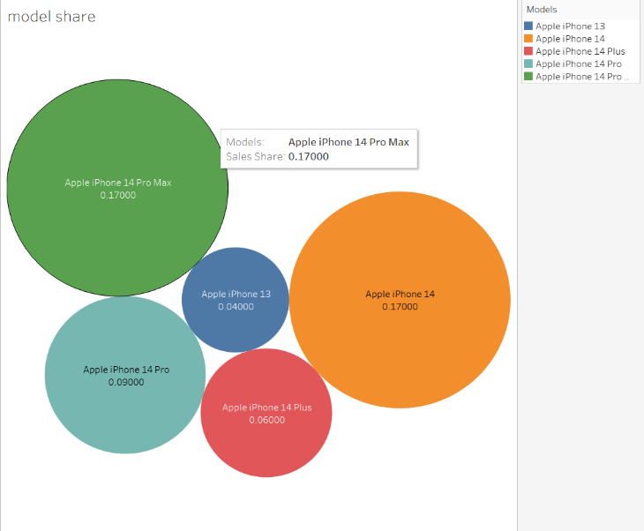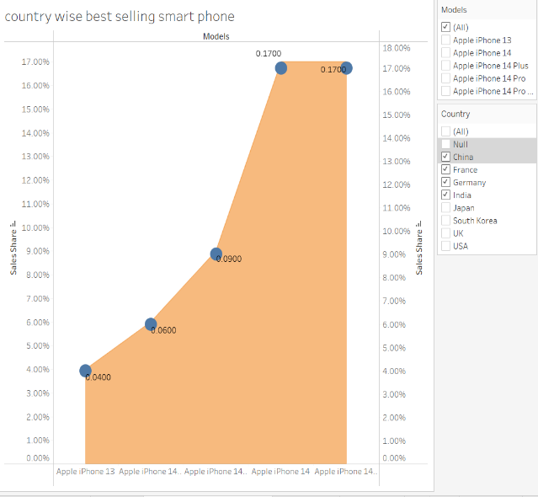

**MODEL SHARE & COUNTRY WISE BESTSELLING SMART PHONE**

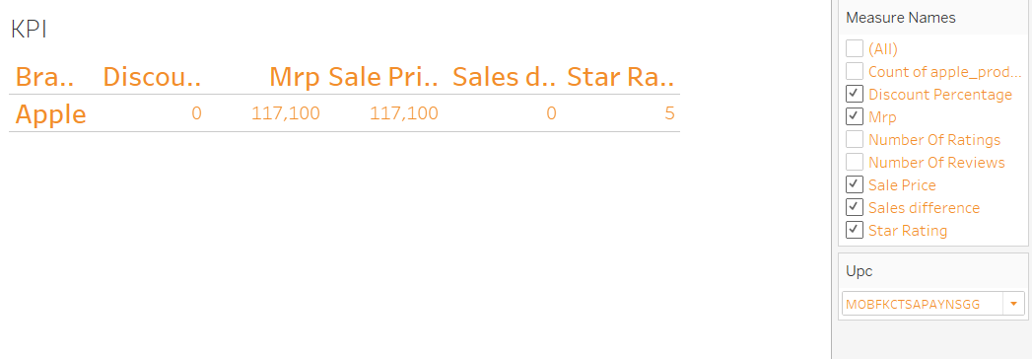

**KPI**

**4.ADVANTAGES & DISADVANTAGES**

**• It will inform that Apple history in India.**

**• It will show Apple makes a big impact in India, especially on iPhone13**

**• It will show the India's global apple market share is improving over the years**

**• this sees Apple introducing a model once a year**

**5.APPLICATION**

**The annual income, global share market, battery type, top-selling smartphones by country, brand price comparison, and other effects of the iPhone are all included in this category.It will demonstrate what has had a greater impact in various nations, particularly India.Additionally, a pricing comparison is included.**

**6.CONCLUSION**

**As of now, we've used data we've gathered to analyze the impact of the iPhone in India, and we've done it using a data visualization tool in the Tableau program.We have created a dashboard and a story that make it possible to make the analysis interactive and user-friendly.**

**7.FUTURE SCOPE**

**Apple iPhones are expected to gain 7% of the Indian smartphone market, which is dominated by Android, thanks to domestic production.To boost their presence in India, the apple corporation plans to open stores in Chennai.The apple business will produce a new Android-based standard in the future.**